**Passing Objects Between Methods**

* **What does pass by value mean?**

Note: In pass by value, the copy of value is passed, it will not change the original value at all.

* **What does “passing by reference” mean?**

* **Passing objects into methods:**

In Java whenever we pass a objects to another method, we are not passing the reference, we copy the pointer of that reference and the pointer is passed.

This means that a copy of pointer to the object is created the object itself is not copied.

Note: There is a misinterpretation that objects are passed by reference but they are not.

* **The final keyword and why it’s not the same as a constant?**

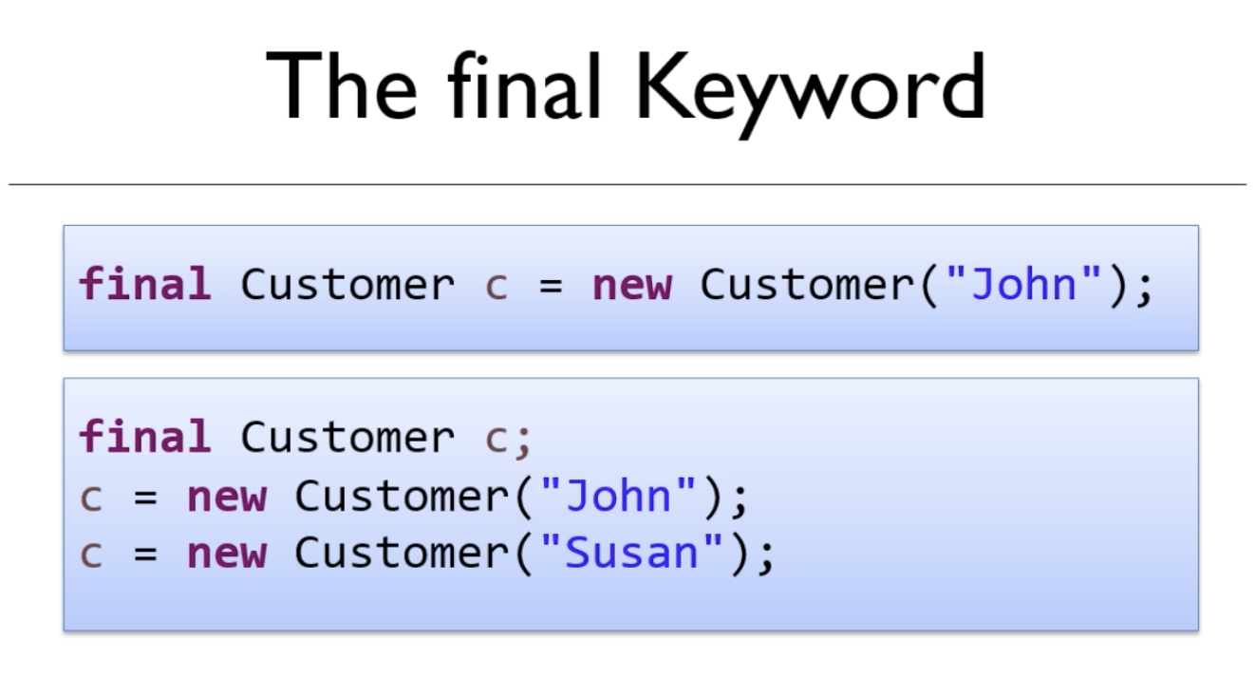

* **Why the final keyword doesn’t stop an object’s values from being changed:**

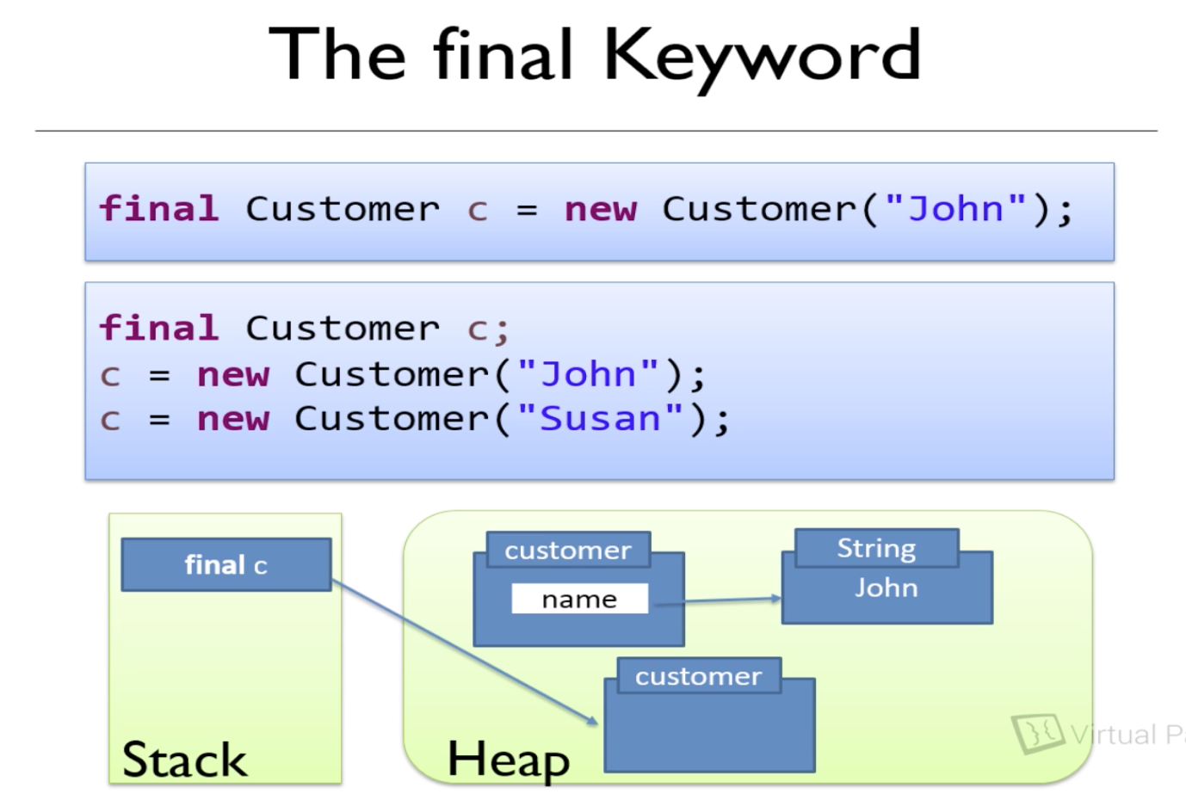

Note: Marking the variable as final improves the performance.